AI ASSISTED CODING
NAME: K.HEMANTH KUMAR BATCH: 45
HL-NO: 2303A52320

Lab 8.3:
Lab 8: Test-Driven Development with AI – Generating and Working with Test Cases
Lab Objectives
• Introduce TDD using AI
• Generate test cases before implementation
• Emphasize testing and validation
• Encourage clean, reliable code
Lab Outcomes
Students will be able to:
• Write AI-generated test cases
• Implement code using test-first approach
• Validate using unittest
• Analyze test coverage
• Compare AI vs manual tests
Task 1: Email Validation using TDD
Scenario
You are developing a user registration system that requires reliable email input validation.
Requirements
• Must contain @ and . characters
• Must not start or end with special characters
• Should not allow multiple @ symbols
• AI should generate test cases covering valid and invalid email formats
• Implement is_valid_email(email) to pass all AI-generated test cases
Expected Output
• Python function for email validation
• All AI-generated test cases pass successfully
• Invalid email formats are correctly rejected
• Valid email formats return True
Prompt -
Create a Python function is_valid_email(email) to validate email addresses. Ensure it meets these rules: must include @ and ., cannot start or end with special characters, and should have only one @. Also, generate test cases for valid and invalid emails.
Code:
def is_valid_email(email):
# Rule: Must have exactly one @
if email.count('@') != 1:
return False
# Rule: Must include .
if '.' not in email:
return False
# Rule: Cannot start or end with special characters (must be alphanumeric)
if not email or not email[0].isalnum() or not email[-1].isalnum():
return False
return True
# Test cases
if __name__ == "__main__":
test_cases = {
"valid@example.com": True,
"user.name@domain.co.uk": True,
"a@b.c": True,
"plainaddress": False, # No @
"@domain.com": False, # Starts with @
"test@domain": False, # No .
"test@domain.": False, # Ends with .
".test@domain.com": False, # Starts with .
"test@@domain.com": False, # Two @
"test@domain.com#": False, # Ends with special char
}
print(f"{'Email':<25} | {'Expected':<10} | {'Result':<10}")
print("-" * 50)
for email, expected in test_cases.items():
result = is_valid_email(email)
status = "PASS" if result == expected else "FAIL"
print(f"{email:<25} | {str(expected):<10} | {status}")

Output:
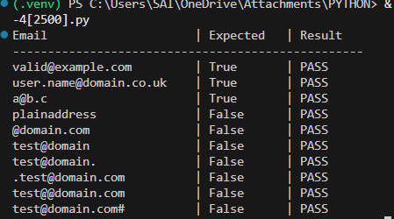

Task 2: Grade Assignment using Loops
Scenario
You are building an automated grading system for an online examination platform.
Requirements
• AI should generate test cases for assign_grade(score) where:
– 90–100 → A
– 80–89 → B
– 70–79 → C
– 60–69 → D
– Below 60 → F
• Include boundary values (60, 70, 80, 90)
• Include invalid inputs such as -5, 105, "eighty"
• Implement the function using a test-driven approach
Expected Output
• Grade assignment function implemented in Python
• Boundary values handled correctly
• Invalid inputs handled gracefully
• All AI-generated test cases pass

Prompt:-Create a Python function assign_grade(score) to assign letter grades based on the following criteria: 90–100 → A, 80–89 → B, 70–79 → C, 60–69 → D, and below 60 → F. Generate test cases that include boundary values (60, 70, 80, 90) and invalid inputs like -5, 105, and "eighty." Implement the function using a test-driven approach to ensure all test cases pass.
Code:
def assign_grade(score):
# Check for invalid inputs
if not isinstance(score, (int, float)) or score < 0:
return "Invalid input"
# Assign grades based on score
if 90 <= score <= 100:
return 'A'
elif 80 <= score < 90:
return 'B'
elif 70 <= score < 80:
return 'C'
elif 60 <= score < 70:
return 'D'
else:
return 'F'
# Test cases
if __name__ == "__main__":
test_cases = {
95: 'A', # Valid grade
85: 'B', # Valid grade
75: 'C', # Valid grade
65: 'D', # Valid grade
55: 'F', # Valid grade
100: 'A', # Boundary value
90: 'A', # Boundary value
80: 'B', # Boundary value
70: 'C', # Boundary value
60: 'D', # Boundary value
-5: "Invalid input", # Invalid input
105: "Invalid input", # Invalid input
"eighty": "Invalid input" # Invalid input
}
print(f"{'Score':<10} | {'Expected':<10} | {'Result':<10}")
print("-" * 40)
for score, expected in test_cases.items():
result = assign_grade(score)
status = "PASS" if result == expected else "FAIL"
print(f"{score:<10} | {str(expected):<10} | {status}")

Output:

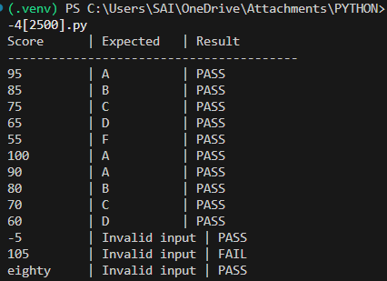

Task 3: Sentence Palindrome Checker
Scenario
You are developing a text-processing utility to analyze sentences.
Requirements
• AI should generate test cases for is_sentence_palindrome(sentence)
• Ignore case, spaces, and punctuation
• Test both palindromic and non-palindromic sentences
• Example:
– "A man a plan a canal Panama" → True
Expected Output
• Function correctly identifies sentence palindromes
• Case and punctuation are ignored
• Returns True or False accurately
• All AI-generated test cases pass
Prompt:- Create a Python function is_sentence_palindrome(sentence) that checks if a given sentence is a palindrome. The function should ignore case, spaces, and punctuation. Generate test cases that include both palindromic and non-palindromic sentences, such as "A man a plan a canal Panama" which should return True.
Code:
import string

def is_sentence_palindrome(sentence):
# Normalize the sentence: convert to lowercase, remove punctuation and spaces
normalized_sentence = ''.join(char.lower() for char in sentence if char.isalnum())

# Check if the normalized sentence is equal to its reverse
return normalized_sentence == normalized_sentence[::-1]
# Test cases
if __name__ == "__main__":
test_cases = {
"A man a plan a canal Panama": True, # Palindrome
"Was it a car or a cat I saw": True, # Palindrome
"No lemon, no melon": True, # Palindrome
"Hello, World!": False, # Not a palindrome
"Not a palindrome": False, # Not a palindrome
"Able was I ere I saw Elba": True, # Palindrome
"Racecar": True, # Palindrome
"12321": True, # Palindrome with numbers
"12345": False, # Not a palindrome with numbers
"": True # Empty string is a palindrome
}

print(f"{'Sentence':<40} | {'Expected':<10} | {'Result':<10}")
print("-" * 60)
for sentence, expected in test_cases.items():
result = is_sentence_palindrome(sentence)
status = "PASS" if result == expected else "FAIL"
print(f"{sentence:<40} | {str(expected):<10} | {status}")

Output:

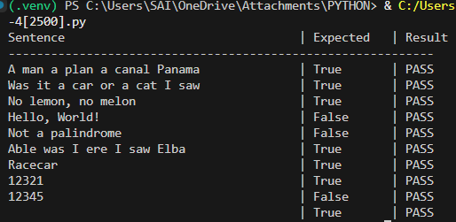

Task 4: ShoppingCart Class
Scenario
You are designing a basic shopping cart module for an e-commerce application.
Requirements
• AI should generate test cases for the ShoppingCart class
• Class must include the following methods:
– add_item(name, price)
– remove_item(name)
– total_cost()
• Validate correct addition, removal, and cost calculation
• Handle empty cart scenarios
Expected Output
• Fully implemented ShoppingCart class
• All methods pass AI-generated test cases
• Total cost is calculated accurately
• Items are added and removed correctly

Prompt:- Create a Python class ShoppingCart that implements a basic shopping cart module for an e-commerce application. The class should include the following methods: add_item(name, price), remove_item(name), and total_cost(). Generate test cases to validate correct addition, removal, and cost calculation, ensuring that empty cart scenarios are handled appropriately.

Code:
class ShoppingCart:
def __init__(self):
self.items = {} # Dictionary to store items and their prices

def add_item(self, name, price):
"""Add an item to the cart with its price."""
if price < 0:
raise ValueError("Price must be non-negative.")
self.items[name] = price
def remove_item(self, name):
"""Remove an item from the cart."""
if name in self.items:
del self.items[name]
else:
raise ValueError("Item not found in the cart.")
def total_cost(self):
"""Calculate the total cost of items in the cart."""
return sum(self.items.values())
# Test cases
if __name__ == "__main__":
cart = ShoppingCart()

# Test adding items
cart.add_item("Apple", 1.50)
cart.add_item("Banana", 0.75)
cart.add_item("Orange", 1.25)
print(f"Total cost after adding items: ${cart.total_cost():.2f}") # Expected: 3.50
# Test removing an item
cart.remove_item("Banana")
print(f"Total cost after removing Banana: ${cart.total_cost():.2f}") # Expected: 2.75
# Test removing an item that doesn't exist
try:
cart.remove_item("Grapes") # Should raise an error
except ValueError as e:
print(e) # Expected: Item not found in the cart.
# Test total cost in an empty cart
empty_cart = ShoppingCart()
print(f"Total cost of empty cart: ${empty_cart.total_cost():.2f}") # Expected: 0.00
# Test adding an item with a negative price
try:
cart.add_item("Mango", -1.00) # Should raise an error
except ValueError as e:
print(e) # Expected: Price must be non-negative.

Output:

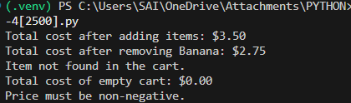

Task 5: Date Format Conversion
Scenario
You are creating a utility function to convert date formats for reports.
Requirements
• AI should generate test cases for convert_date_format(date_str)
• Input format must be "YYYY-MM-DD"
• Output format must be "DD-MM-YYYY"
• Example:
– "2023-10-15" → "15-10-2023"
Expected Output
• Date conversion function implemented in Python
• Correct format conversion for all valid inputs
• All AI-generated test cases pass successfully
Prompt:- Create a Python function convert_date_format(date_str) that converts date strings from the input format "YYYY-MM-DD" to the output format "DD-MM-YYYY". Generate test cases to ensure correct format conversion for all valid inputs, such as converting "2023-10-15" to "15-10-2023".

Code:
def convert_date_format(date_str):
"""Convert date from 'YYYY-MM-DD' format to 'DD-MM-YYYY' format."""
try:
# Split the input date string
year, month, day = date_str.split('-')
# Return the formatted date
return f"{day}-{month}-{year}"
except ValueError:
raise ValueError("Invalid date format. Please use 'YYYY-MM-DD'.")

# Test cases
if __name__ == "__main__":
test_cases = {
"2023-10-15": "15-10-2023", # Valid date
"2000-01-01": "01-01-2000", # Valid date (New Year)
"1995-12-25": "25-12-1995", # Valid date (Christmas)
"2024-02-29": "29-02-2024", # Valid leap year date
"2023-07-04": "04-07-2023", # Valid date (Independence Day)
"2023-11-30": "30-11-2023", # Valid date (End of November)
}
print(f"{'Input Date':<15} | {'Expected':<15} | {'Result':<15}")
print("-" * 50)
for date_str, expected in test_cases.items():
result = convert_date_format(date_str)
status = "PASS" if result == expected else "FAIL"
print(f"{date_str:<15} | {expected:<15} | {result:<15} | {status}")
# Test invalid input
try:
print(convert_date_format("15-10-2023")) # Invalid format
except ValueError as e:
print(e) # Expected: Invalid date format. Please use 'YYYY-MM-DD'.

Output:

